­­­Jaden Booher

January 27, 2020

Project 2

1. 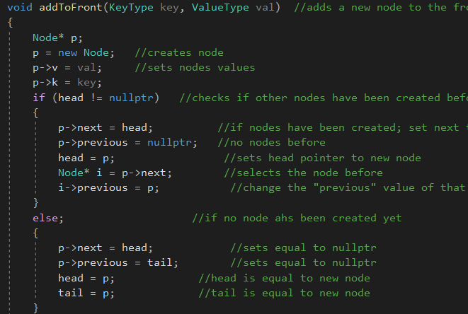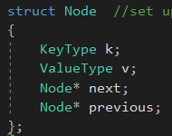Implementation of the double linked list
   1. Established an “head” and “tail” node
   2. Node would store 4 items: “key” string, “value” double, “next” pointer (pointing to the next node in the list), and the “previous” pointer (pointing to the previous node in the list)
   3. Each new node created (in the “addToFront” command) would store the “key,” the “value,” and “next” address; “previous” address would be set to “nullptr” since nothing comes before it on the list
   4. Used a pointer to the node which came before the created node to set the “previous” address in that node to the one just created before

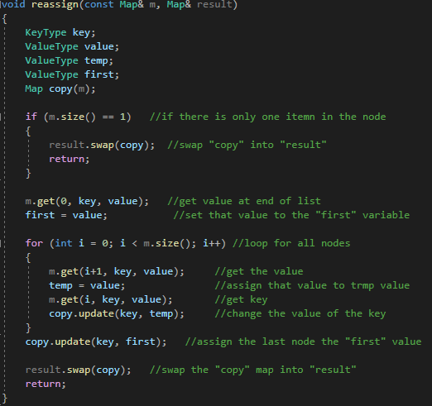

1. 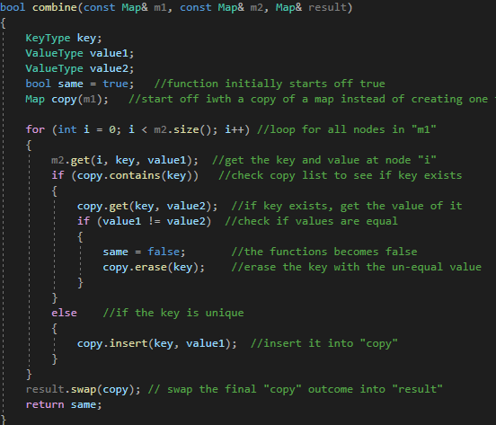Pseudocode for non-trivial algorithms

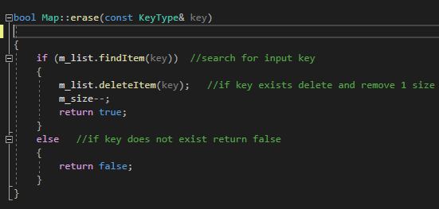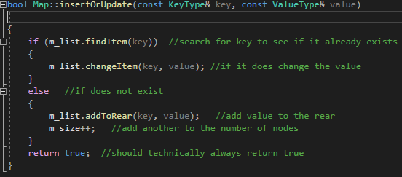

1. 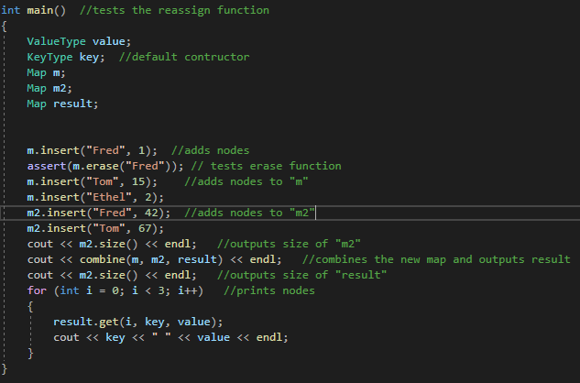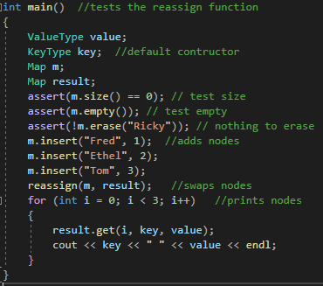Test cases

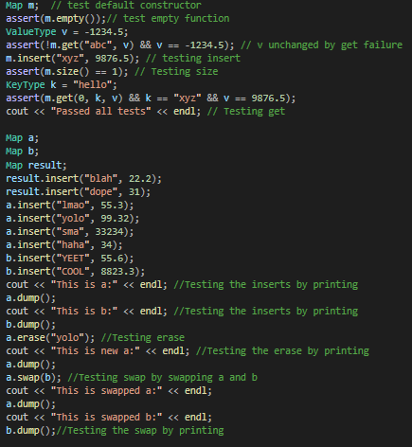

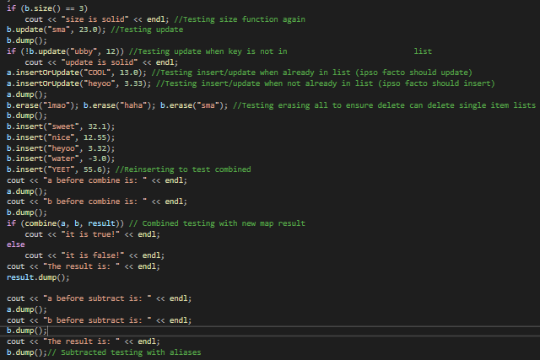 <- this one first

Then this |